Add Icon on Dashboard

1. Go to \Views\Dashboard\_icons.cshtml
2. Define Correct Permission

@if (LIB.Tools.Security.Authentication.GetCurrentUser().HasAtLeastOnePermission((long)LIB.BusinessObjects.BasePermissionenum.VenueAdmin))

{

}

1. Add Icon in the parentheses

*Example 1: FROM*

<a href="@LIB.Tools.Utils.URLHelper.GetUrl("DocControl/Test")" target="_blank" class="dashboard-ico dashboard-ico-reports">

<div class="outer-ico">

<div class="inner-ico">

<div class="dashboard-icon">

@Html.Raw(MedCore.Helpers.T.Str("Add Test", "DashBoard", "Add <br/> Test "))

</div>

</div>

</div>

</a>

* DocControl – built in controller for Form process.

MedCore.Helpers.T.Str (string alias, string ResourceFile, string defaultvalue="")

– translates strings from res files.

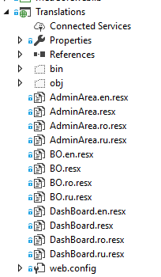

*Example 2: REPORT*

<a href="@LIB.Tools.Utils.URLHelper.GetUrl("Report/ TestList")" target="_blank" class="dashboard-ico dashboard-ico-paginasectia">

<div class="outer-ico">

<div class="inner-ico">

<div class="dashboard-icon">

@Html.Raw(MedCore.Helpers.T.Str("ReportLits", "DashBoard", "Report <br/> Tests "))

</div>

</div>

</div>

</a>

Report – built in controller for Report process.